Create M3 Notification in Android version

- Open the Android app Svc&AssetMgr
    - 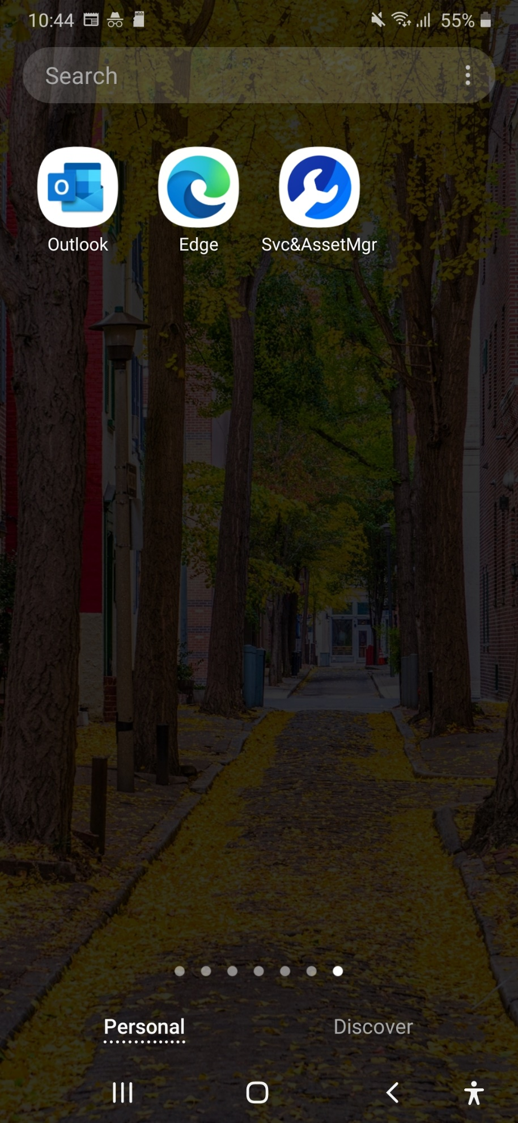
- You will see below landing page once you open app
  - 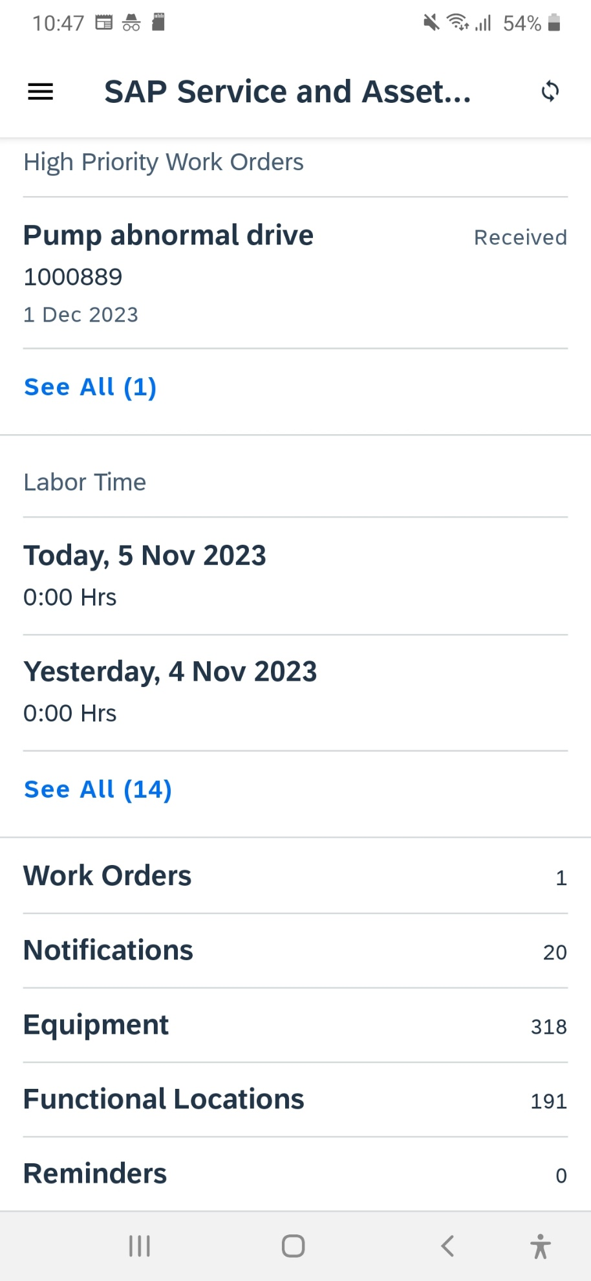

- Click on Notifications
- 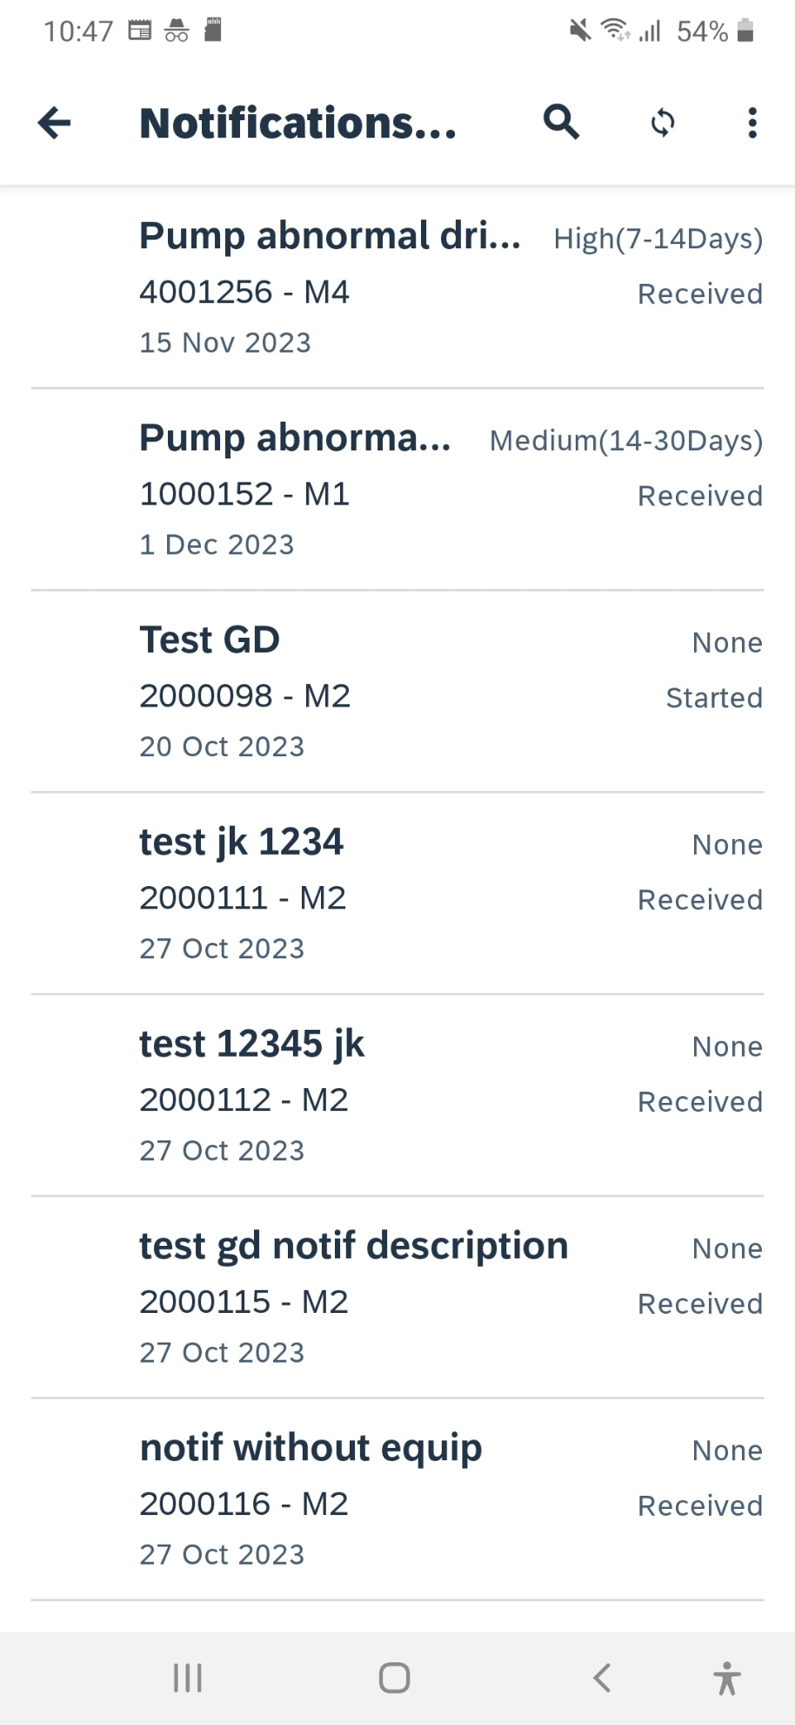

- You will see your existing notifications here
  - 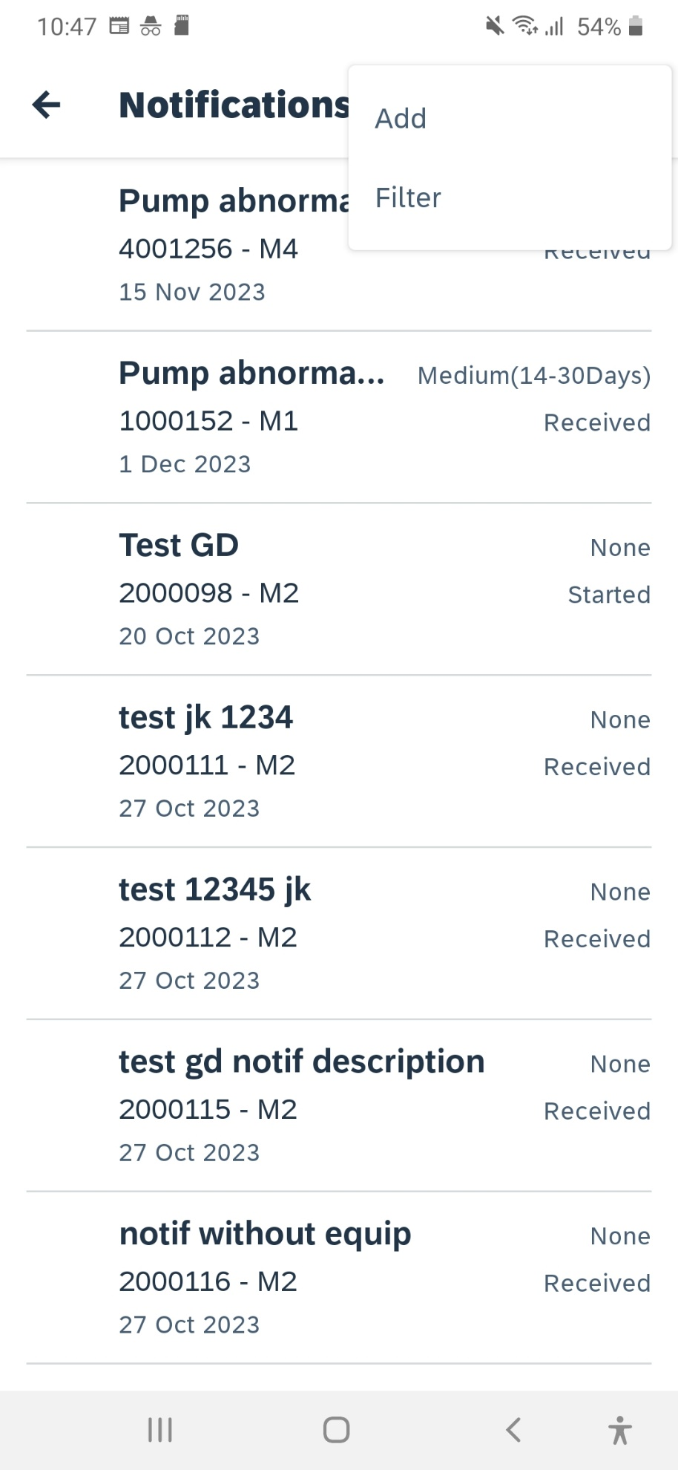

- Click on the three dots, you will add new notifications options
- 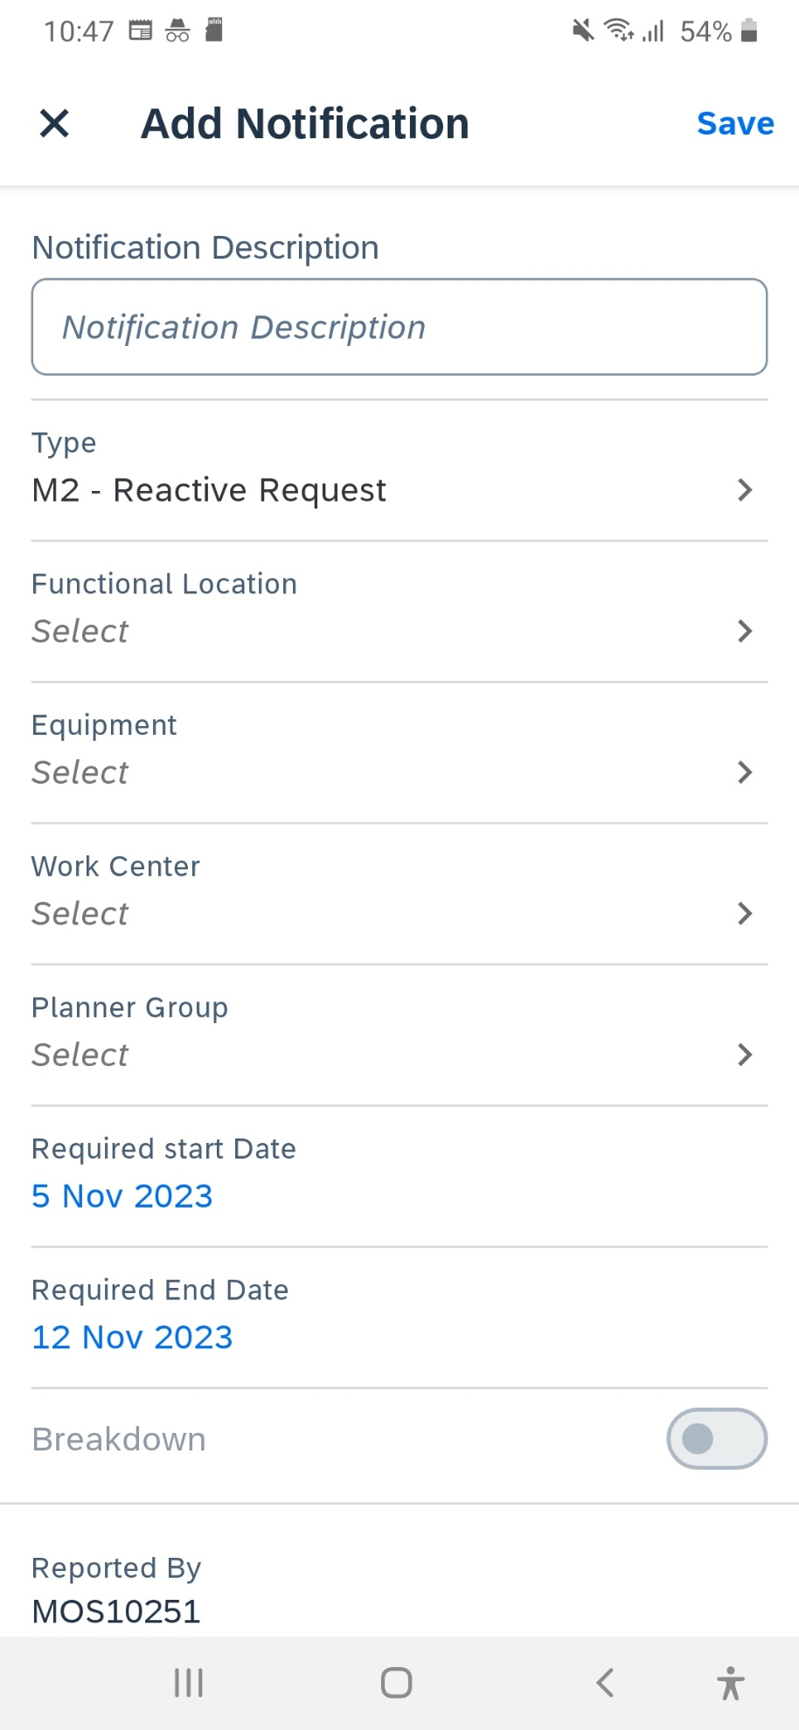

- You will see your M2 notifications empty form here with additional fields
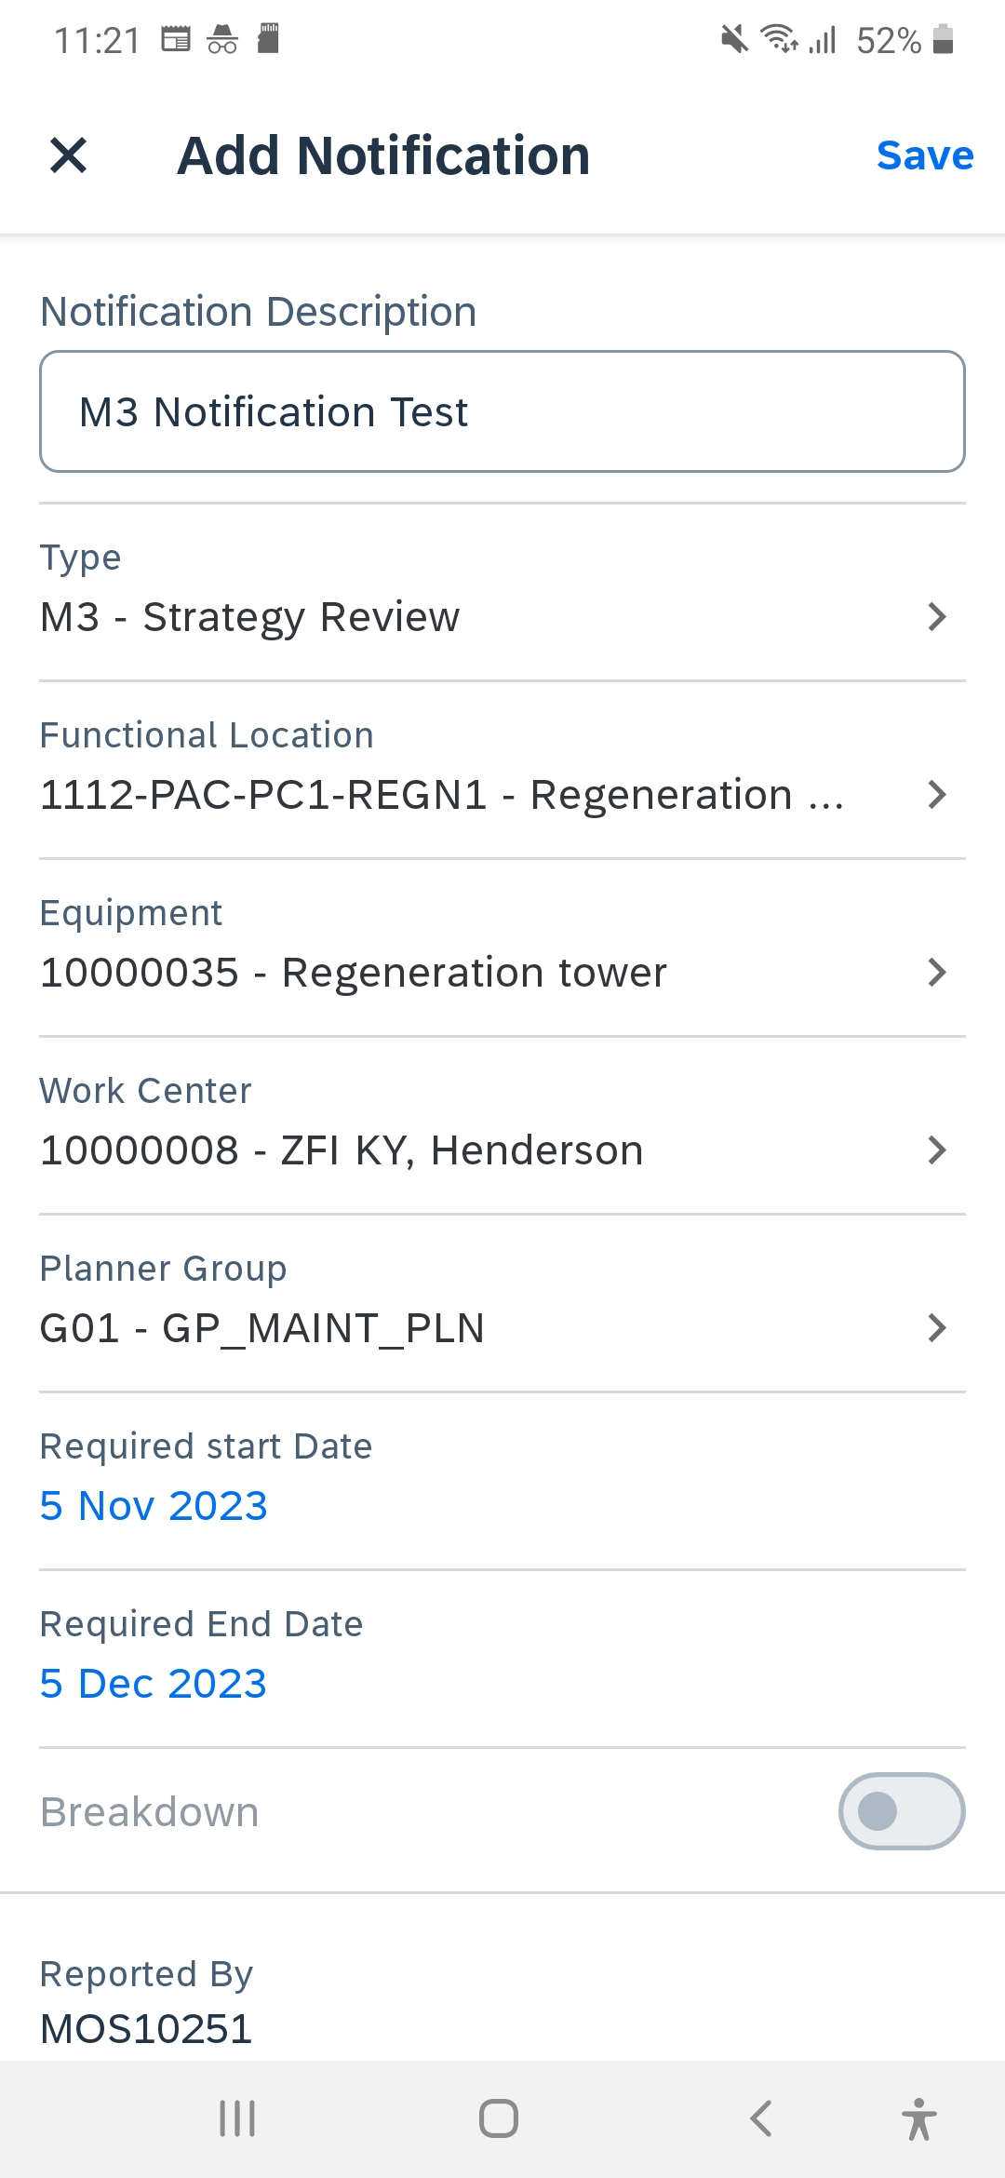

- Enter all the mandatory fields and click on Save
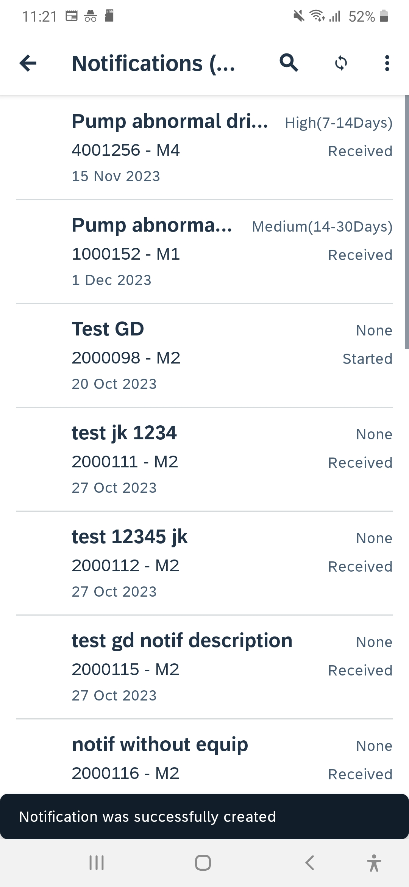

- You will get a success message as above

- If you check the notification it will be saved in Local device
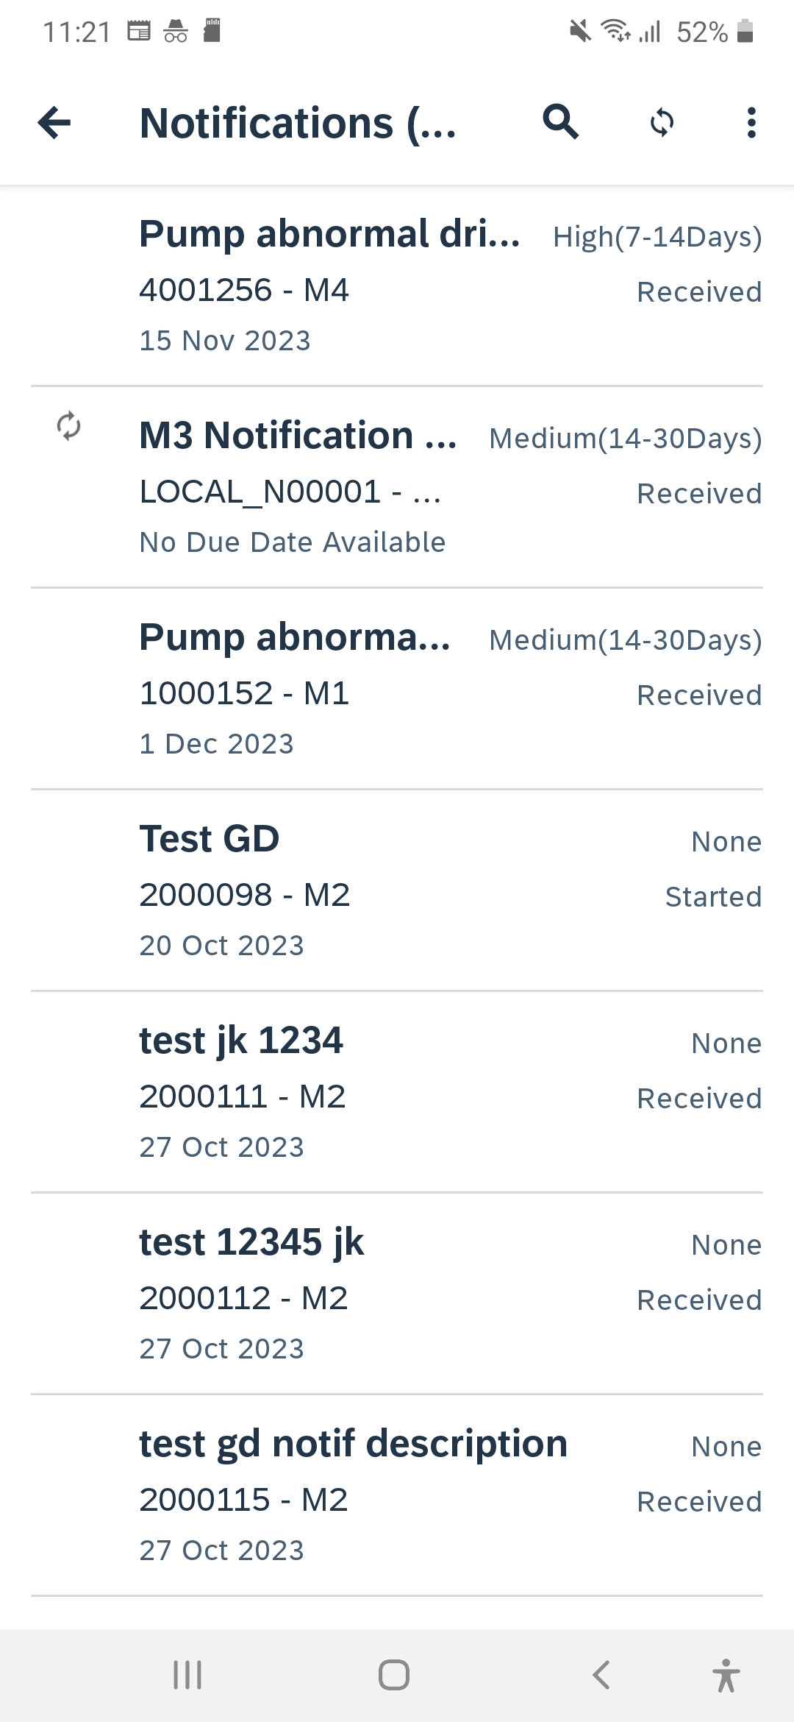

- Click on the sync icon to save it to SAP
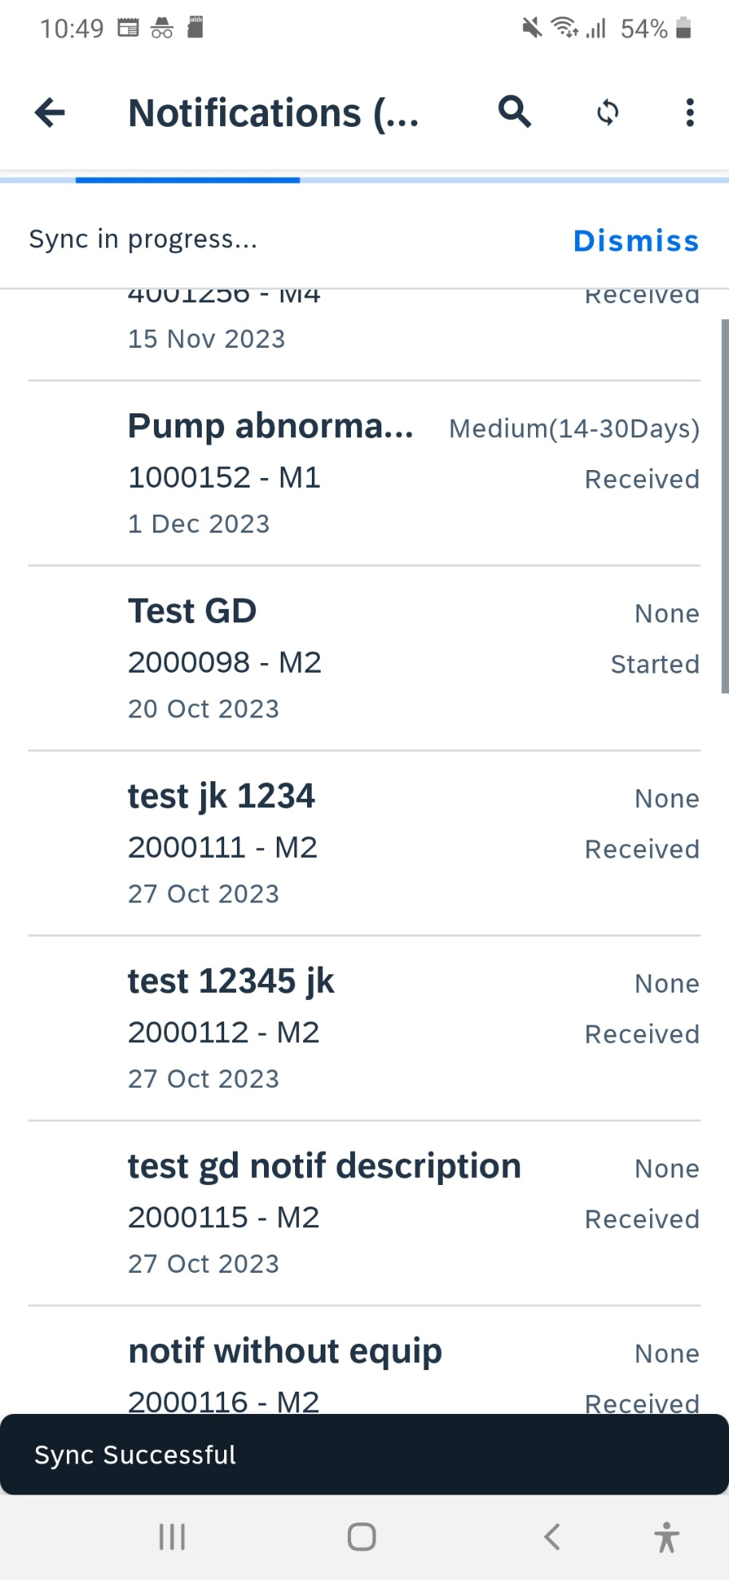

- You will get sync success message as above
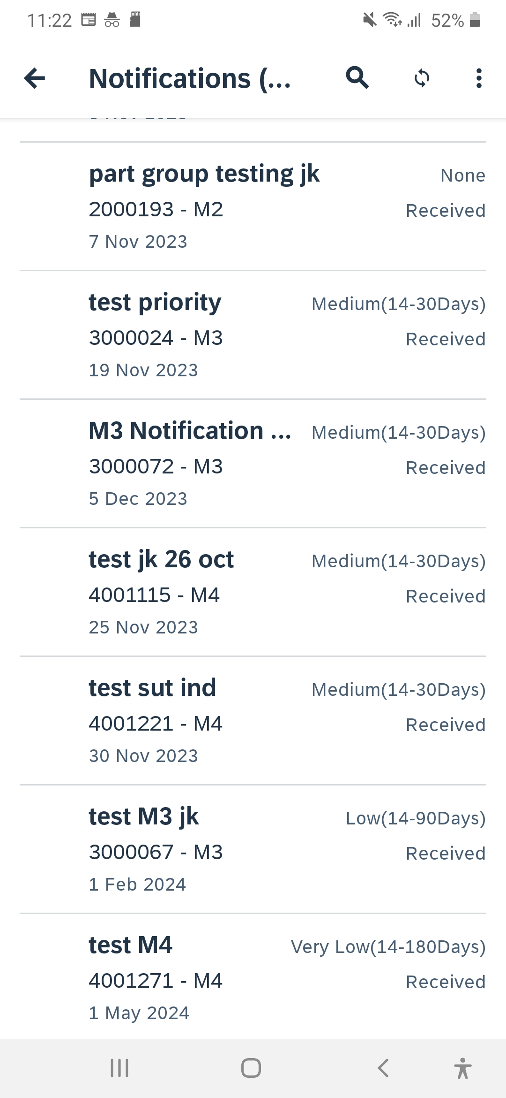
- Check the notification is moved from LOCAL to SAP
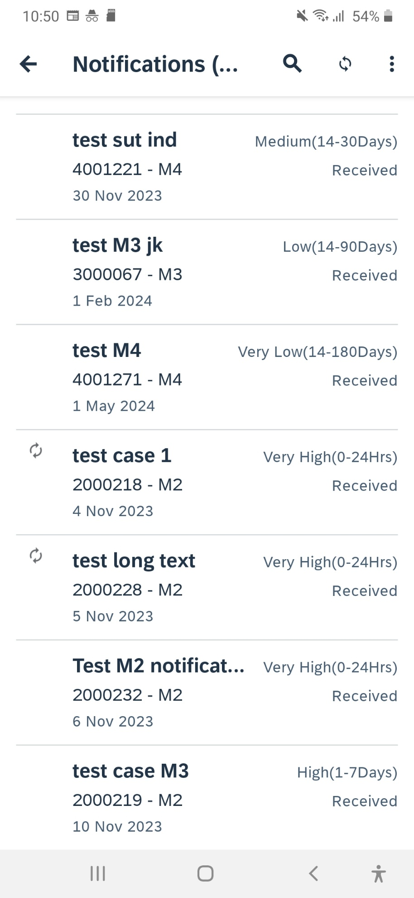

- Check the notification if all the save data is available
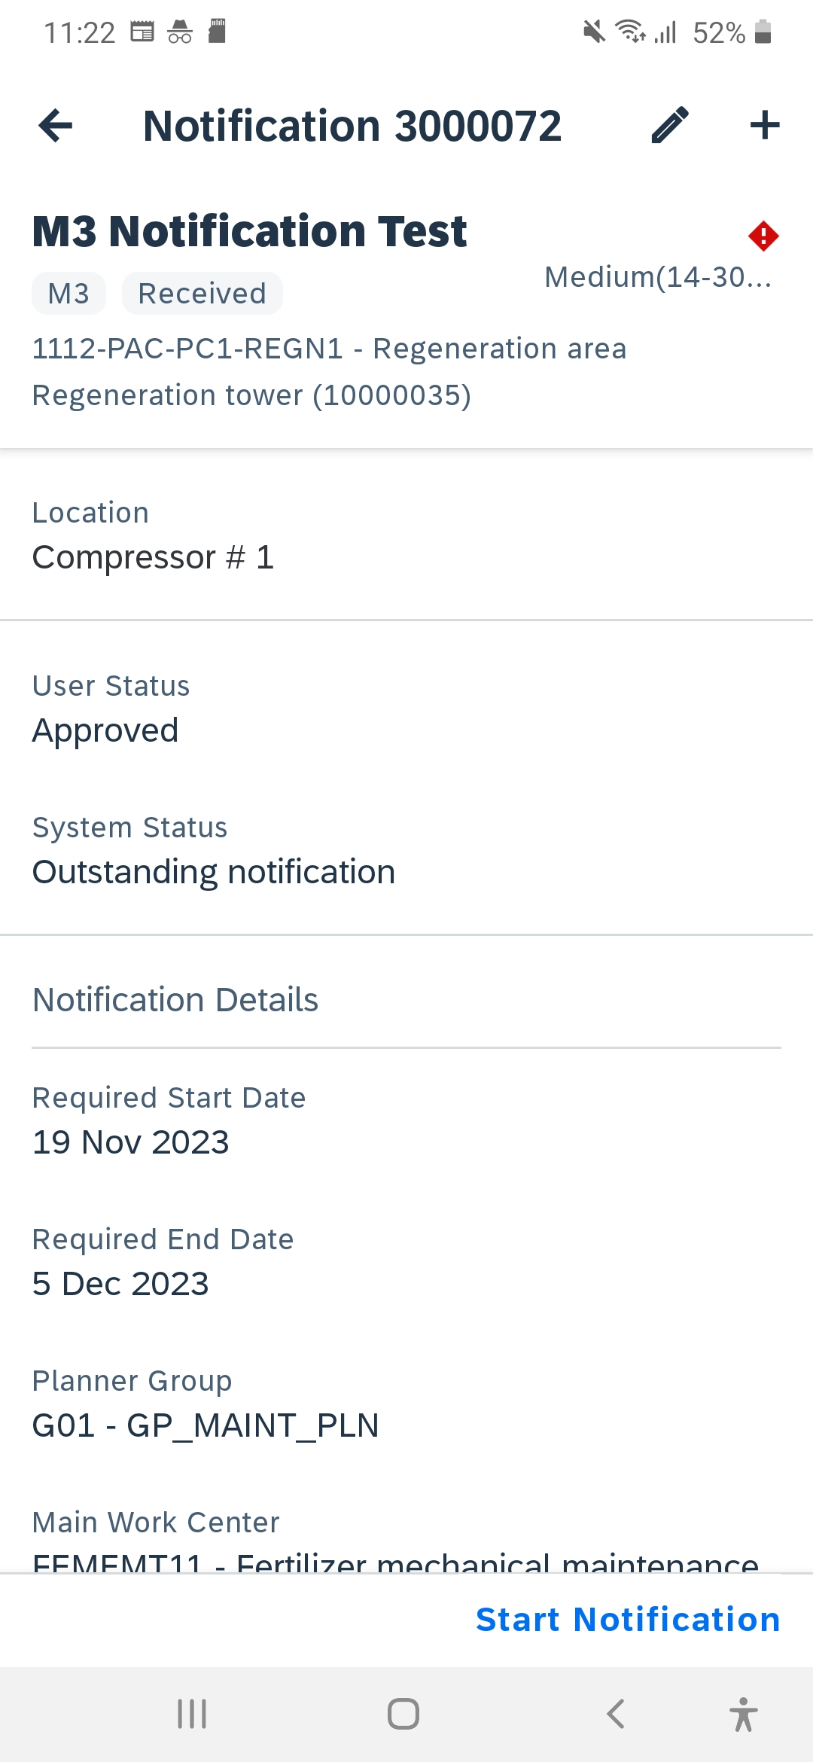
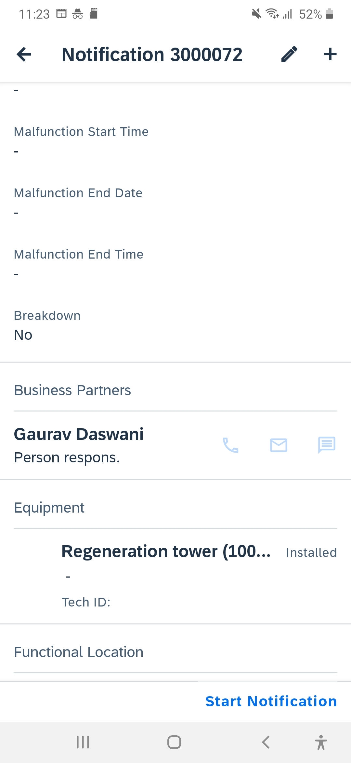
- Test Successful

